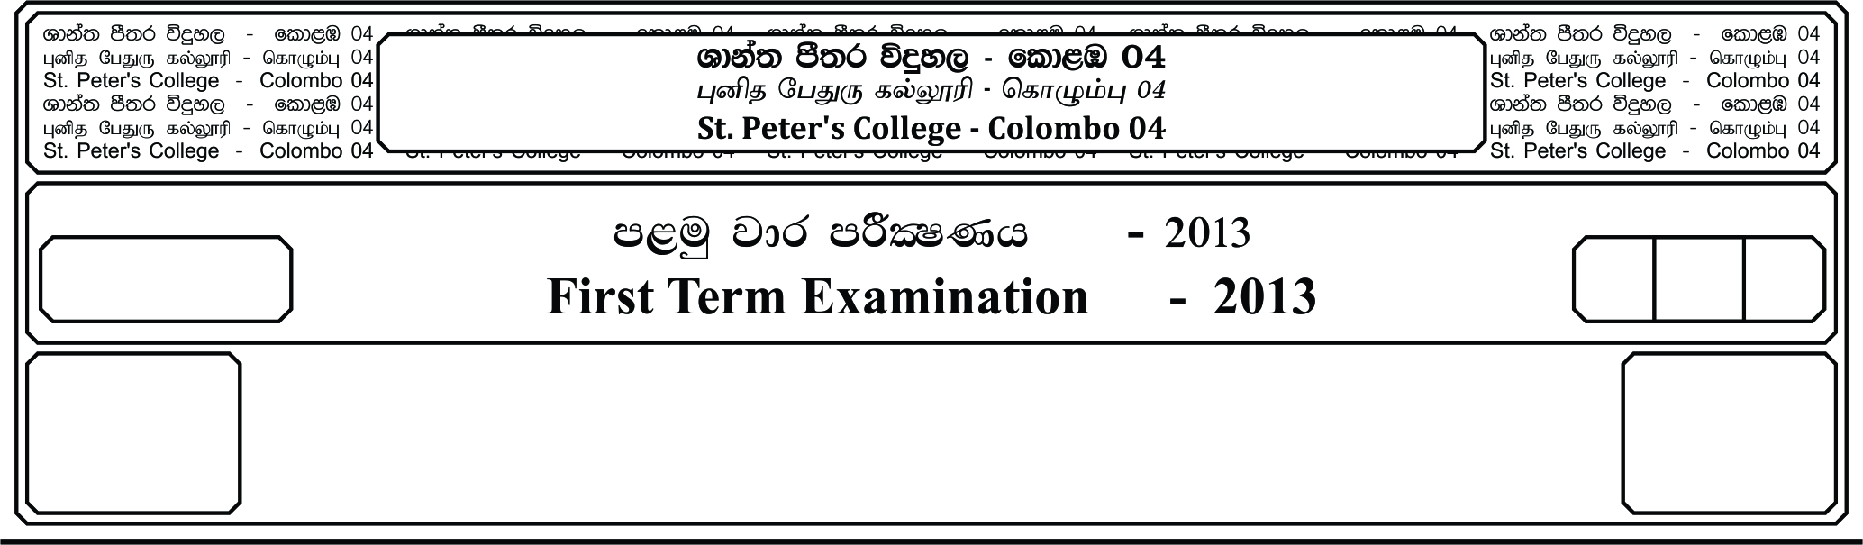

E

**idudkH bx.%Sis -** II

**English – II**

**m<uq jdr mÍCIKh - 2019**

**Third Term Examination - 2019**

meh 03

03 Hour

13 fY%aKsh

GRADE 13

II

**Reading skills.**

01. Select the correct meaningful word from the list given below and fill the blanks.

Starting a **(1)** ……….……………..… data entry business is easier than trying to work from job to job.

Having a business means that people will come to your business whenever they need a service you

**(2)** ……….…………… This also means that instead of having to always **(3)** ……….…………… for jobs

on freelancing websites, you will be able to have clients come to you as needed. One important thing to

**(4)** ……….…………… when starting a data entry business is that customer service is really important.

It’s hard to get anywhere in the data entry field if you don’t provide your customers with all the services

they need. It’s important that you take your time to really care for your customers completely. Once you

are ready to start your data entry business it’s time to start building a great team. You want to have a team

that can do a **(5)** ……….…………… range of task so that your business can fill customer’s needs. You

want to always test your team before giving them the task of working with a client.

1. A. Complete B. Half complete C. Blank D. Intact E. Enhaustive

2. A. Bid B. Advance C. Refuse D. Offer E. Pitch

3. A. Assign B. Apply C. After D. Appeal E. Demand

4. A. Forgive B. Remember C. Discount D. Fail E. Forget

5. A. Narrow B. Broad C. Wide D. Open E. Restricted

**10 Marks**

02. Read the poem and answer the questions below.

**The Fog**

I saw, the fog grow thick

Which soon made blind my Ken;

It made tall men of boys,

And giants of all men

If clutched my throat, I coughed;

Nothing was in my head

Except two heave eyes

Like balls of burning lead.

And when it grew so black

That I could know no place

I lost all judgments then

Of distance or of space

**05 Marks**

The street lamps and the lights.

Upon the halted cars,

Could either be on earth

Or be the heavenly stars

A man passed by me close,

I asked my way, he said

“Come, follow me, my friend….”

I followed where he led.

He rapped the stones in front,

“Trust me”, he said, “and come”

I followed like a child

A blind man led me home.

**W. H. Davis**

1. “It clutched my throat, I coughed” tells us that

i. The poet was suffering because of the fog.

ii. The fog stopped the poet coughing.

iii. The poet had a sore throat.

2. Which of the following statement is not true

i. The fog caused the poet to see things differently.

ii. The fog hurt the poet’s eye.

iii. A blind man who was also lost came to help the poet.

03. The word halted shows that the cars were probably

i. Moving ii. Parked iii. Stolen

04. ‘……… the stones in front in the last stanza refers to,

i. The stones that were lying in their way.

ii. The road they were walking along.

iii. Loose gravel lying by the side of the road.

05. The blind man could lead the poet through the fog because he,

i. Had been to the poet’s house.

ii. Was directed by the fog.

iii. Knew the way to the poet’s house. **05 Marks**

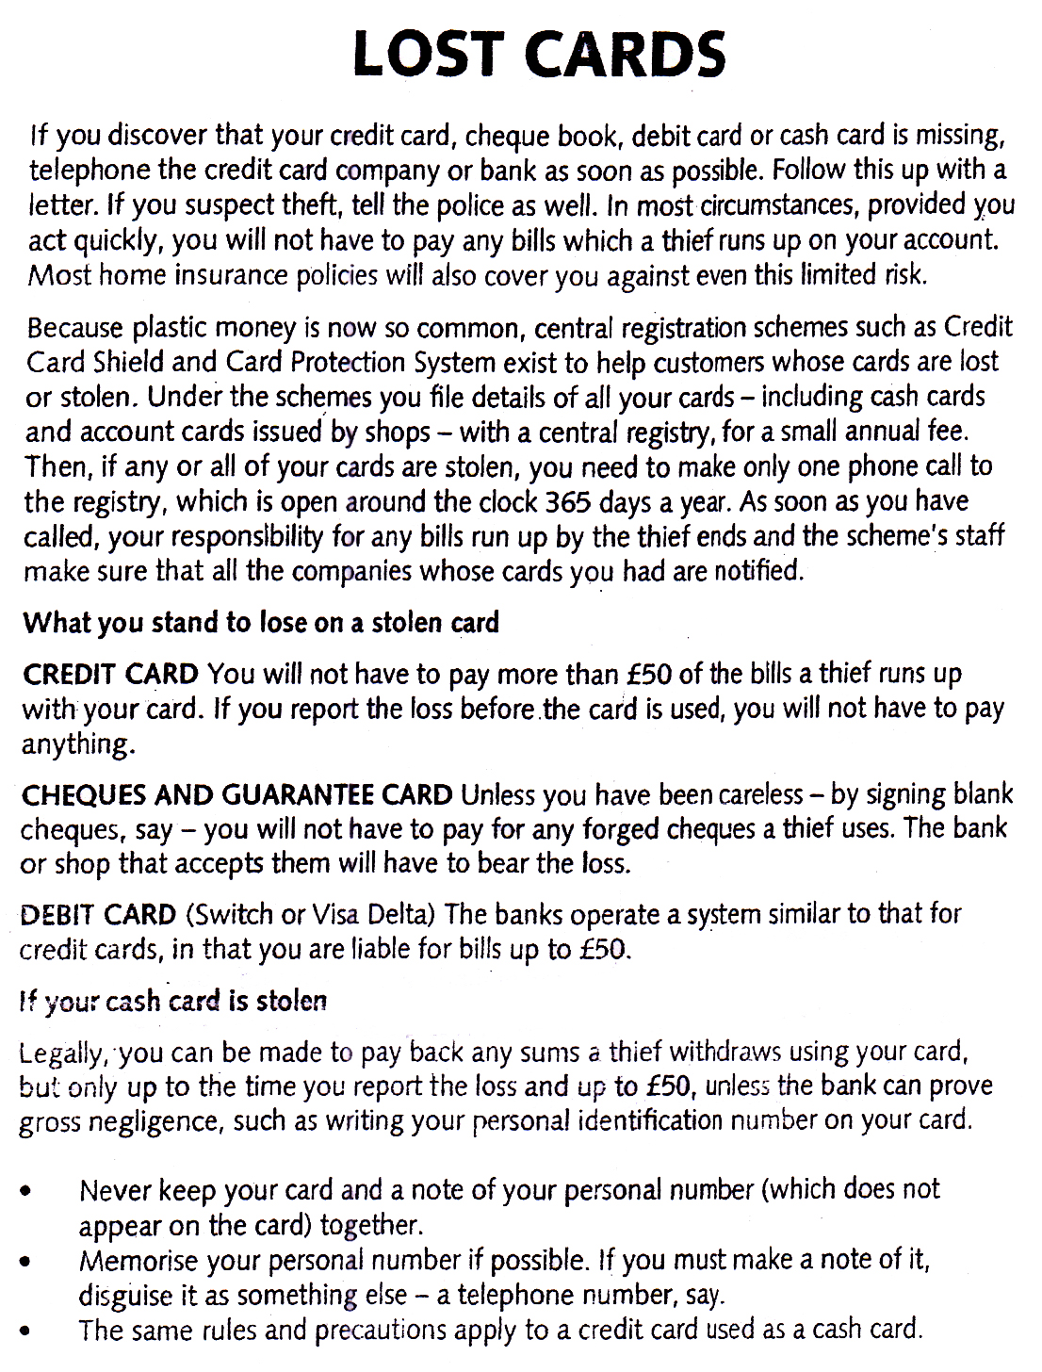

04. Summaries the following passage in 35 words.

To have an interesting conversation, one should be well informed on a variety of subjects including

the hot topics of the day which can be religion, politics, major happenings or incidences local or

foreign. Reading should be made a regular habit. It is important to set aside a particular time for reading

of newspapers and magazines. This should be not only out of interest but also to keep abreast of news.

This practice ensures not only one’s keeping pace with local and world events, but also one’s ability

to carry on discussion with people of different interests. The knowledge of various subjects gives self-

confidence, which is the most essential ingredient of conversation.

|  |  |  |  |  |  |  |
| --- | --- | --- | --- | --- | --- | --- |
|  |  |  |  |  |  |  |
|  |  |  |  |  |  |  |
|  |  |  |  |  |  |  |
|  |  |  |  |  |  |  |
|  |  |  |  |  |  |  |

Read the text and answer the following questions.

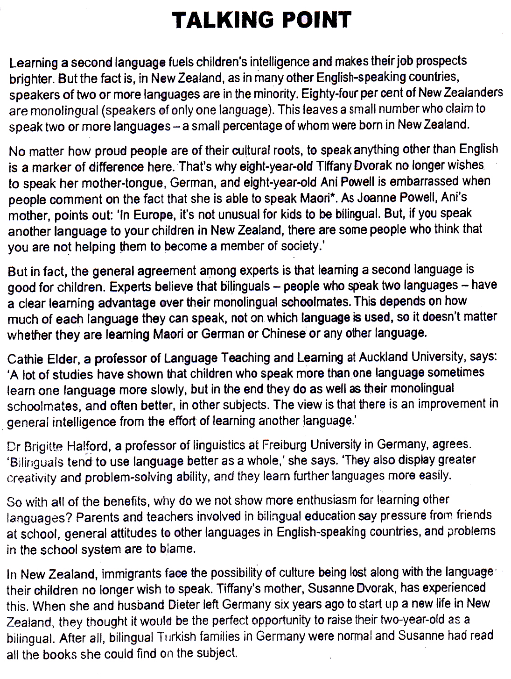

01. Do the following statements agree with the information given in the text?

***TRUE*** - if the statement agrees with the information

***FALSE*** - if the statement contradicts the information

***NOT GIVEN*** - if there is no information on this

1. Most people who speak a second language in New Zealand were born in another country.

2. Most New Zealanders believe it is good to teach children a second language.

3. Chinese is the most common foreign language in New Zealand.

4. Some languages develop your intelligence more than others. **04 Marks**

Look at the following statements and the list of people below.

Match each statement with the correct person, ***A-E***

Write the correct letter in the box given.

***NB*** You may use any letter more than once.

Children learning two languages may learn one language faster.

It has been unexpectedly difficult to raise a bilingual child in New Zealand.

Her daughter sometimes speaks a mixture of two languages.

Children’s attitudes to language depend on general social attitudes.

It is not important which language parents speak with, their children.

Learning second language provides opportunities to learn another culture.

Speaking a second language provides work opportunities.

**07 Marks**

**List of People**

**A** Cathie Elder

**B** Brigitte Halford

**C** Susanne Dvorak

**D** Joanne Powell

**E** Donna Chan

Choose ***TWO*** letters, ***A-F***

Write the correct letters in box.

Which **TWO** people stopped speaking one language as a child?

**A** Donna Chan

**B** Susanne Dvorak

**C** Tiffany Dvorak

**D** Cathie Elder

**E** Brigitte Halford

**F** Joanne Powell

**04 Marks**

Choose ***TWO*** letters, ***A-F***. Write the correct letters in box.

Which **TWO** people think that their children’s language may develop as they get older?

**A** Donna Chan

**B** Susanne Dvorak

**C** Tiffany Dvorak

**D** Cathie Elder

**E** Brigitte Halford

**F** Joanne Powell **04 Marks**

**(20 Marks)**

**Dialogues**

06. Match A and B to form a meaningful dialogue.

**A B**

How was your examination Yes I’m happy for my results

So, you’ve passed? I intend to do higher studies

Congratulations! Not so bad really. It was much easier than

You have done better than last time I expected.

What are you plans for the future Thank You.

I wish you all the best. Yes I have.  **05 Marks**

07. You have received a letter from your bank, asking you to acknowledge receipt of a new **ATM** card.

However, the card was missing from the envelope. You go to the bank and meet the officer at the

information desk. Use the given guidelines and complete the dialogue between two of you.

Officer :- “Good morning can I help you please?”

You :- ……………………………………………………………………………………

Officer :- “Oh, really ………………………………………………………… (ask for the letter)”

You :- …………………………………………………………………… (give him the letter)

Officer :- This can be a mistake. But we’ve never had a complaint like this. Anyway ……………

…………………………………………………………………………(request you to

meet the bank manager)

You :- ……………………………………………………………………………………………

Officer :- “He’s at a meeting now. He’ll come in ten minutes. Could you sit here until he comes.”

You :- ……………………………………………………………………………… **05 Marks**

08. Your class is planning to go on a trip to see the ancient cities of Sri Lanka. You want to stay at ‘Araliya

Rest’. On the first day. You are speaking to the manager of ‘Araliya Rest’ to get the information you

need. Write out the telephone conversation you will have with manager. Each one should speak at least

05 times. **15 Marks**

09. Construct 5 meaningful sentence from the list given below.

Courteous , deterrent , alleged , arrested , complaint abscond , reprehensible , aggressive , intolerance

Habbed **05 Marks**



10.

1. Read the graph and make questions for the following short answers.

1. Samsung

2. HTC and Motorola

3. Apple iPhone

4. Others.

5. Smartphone Brand Market share

2. Fill the blanks with a suitable word.

Apple iPhone and Samsung are popular ……………………. Smartphones in ……………………. LG

and other smartphones are more ……………………. Compared to Motorola and HTC This graph

gives a detail share ……………………. On the ……………………. brands.

11. **Writing**

Your friend has asked to meet you at the weekend. You need to decide whether you want to go swimming or go to the cinema. Write an email to your friend.

♦ Accept your friend’s invitation to meet.

♦ State which activity you would like to do.

♦ Explain why you would prefer that activity.

You **must** write between **75 and 100 words only.**

____________________________________________________________________________________________________________________________________________________________________________________________________________________________________________________________________________________________________________________________________________________________________________________________________________________________________________________________________________________________________________________________________________________________________________________________________________________________________________________________________________________________________________________________________________________________________________________________________________________________________________________________________________________________________________________________________________________________________________________________________________________________________________________________________________________________________________________________________________________________________________________________________________________________________________________________________________________________________________________________________________________________________________________________________________________________________________________________________________________________________________________________________________________________________________________________________________________________________________________________________________________________________________________________________________________________________________________________________________________________________________________________________________________________________________________________________________________________________________________________________________________________________________________________________________________________________________________________________________________________________________________________________________________________________________________________________________________________________________________________________________________________________________________________________________________________________________________________________________________________________________________________________

**(15 Marks)**

12. Write a letter to the P.H.I of the department of health, informing him the inconvenience cause due to

piled up garbage in your area. **(15 Marks)**

13. Write an essay from one of the following topics in 175 – 200 words.

i. Using a computer every day can have more negative than positive effects on children. Do

you agree or disagree.

**or**

ii. As a student you may be having many goals in your life. Talk about 3 specifics goals you

want to accomplish, and how you are going to achieve that target.

**(20 Marks)**